Use “root” to login and type the “password” created during “Administration Password and E-mail Address”.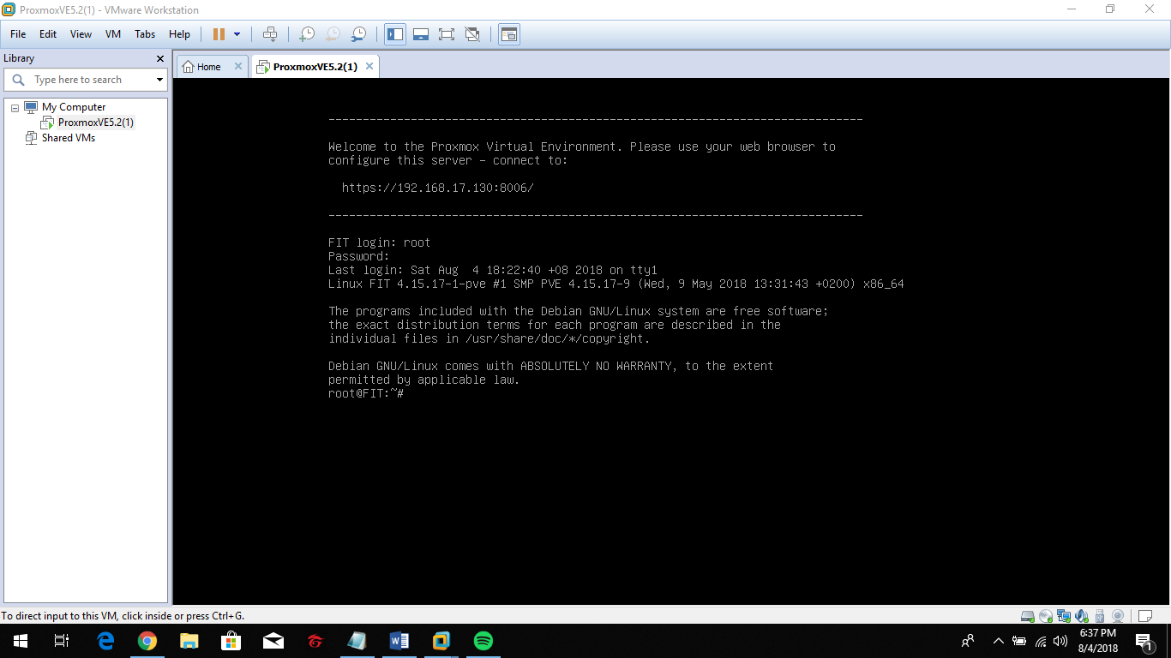

Ping google by typing the command “ping -c 3 [www.google.com](http://www.google.com)” to secure connection.

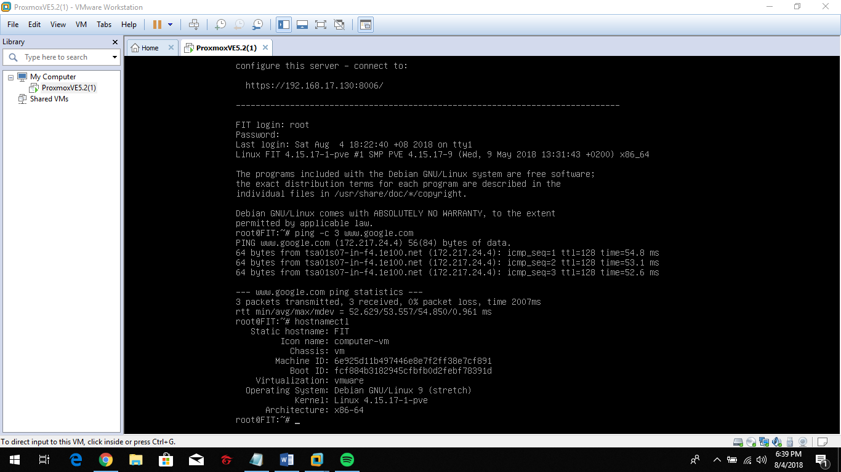

Type “hostnamectl” command to verify information.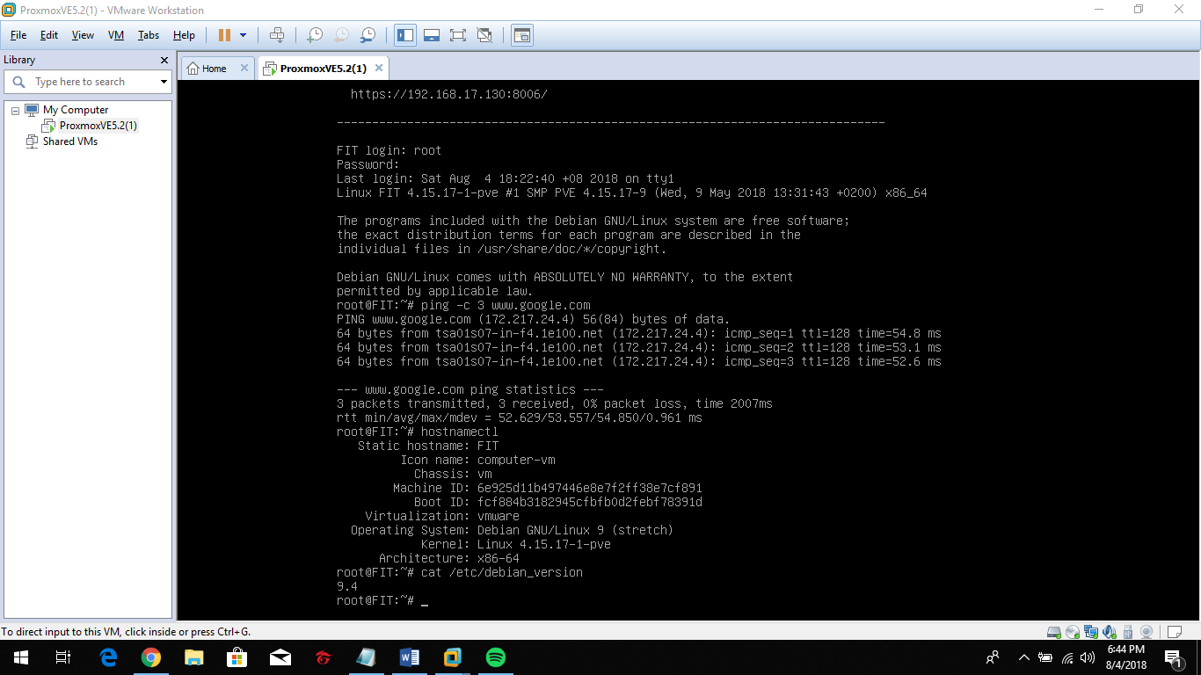

Type “cat /etc/debian_version” to check the version of operating system.